MatchUp

Table of Contents

- Problem Statement
In my research, I found that wedding planning today is an emotionally high-stakes, logistically dense process, typically spread across a wedding-planning hub, a spreadsheet, and one or more single-purpose tools. I identified two tasks that consistently create the most stress for couples: keeping the budget under control, and building a seating chart that does not cause family conflict. I found that existing apps address both tasks only on the surface.

Why budget overspend is a problem existing apps do not solve
Through my research, I found that the average U.S. wedding now costs around $36,000 (1), and most couples end up spending more than they originally planned, with hidden and unplanned costs commonly adding several thousand dollars beyond their initial vendor quotes (2). When I examined the budget tools inside apps such as Zola, I found category allocation and payment reminders, and I noted that Zola has recently added predictive warnings that flag likely overspend (3), but this warning arrives after the couple is already close to, or past, the danger point. I also reviewed WeddingWire's free budget tool and found that it tracks vendor payments well but does not connect spending to the rest of the plan or suggest what to do next (4). In both cases, I concluded that the couple is simply told there is a problem; neither app helps them solve it in the moment.

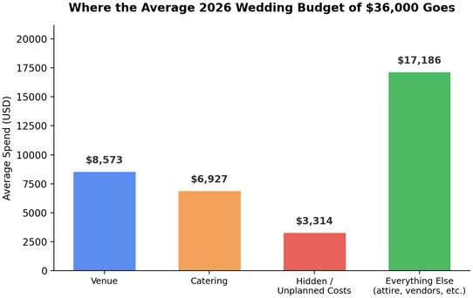

Figure 1: Where the average 2026 wedding budget of $36,000 goes (2).

Why seating is a problem existing apps do not solve
I found seating to be repeatedly named by couples and planners as the most stressful single task in the entire process (5), because it is really a social-conflict problem disguised as a layout problem: divorced parents, feuding relatives, guests who barely know each other, and unbalanced tables all need to be considered at once. I

noted that Zola sells its seating chart as a paid, $14.99 add-on (6), and it is still a manual drag-and-drop canvas. When I reviewed WeddingWire and dedicated tools such as AllSeated, I found polished drag-and-drop functionality and even 3D visualisation, with charts that export cleanly (7), but none of them understand relationships between guests; the couple still has to hold every family conflict in their head while dragging names around a floor plan. I also noted that AllSeated, which has recently rebranded as Prismm, is built for professional planners, with paid tiers that make it costly and complex for a couple doing this only once (8).

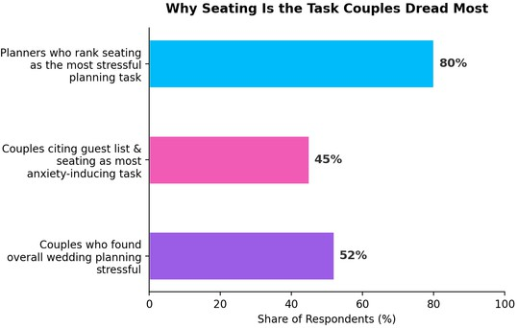

Figure 2: Independent surveys on why seating is the task couples dread most (5, 10).

Why AI in existing apps is not enough
I observed that several platforms now advertise AI, but I found this support to be narrow: Zola AI is scoped to drafting thank-you messages (9), not to helping a couple make a budget or seating decision. Through my research, I found no existing product where a couple can ask a single assistant, in plain language, 'we're over on catering, what should we adjust' or 'where should my divorced parents sit,' and get a considered answer grounded in their own guest list and budget.
The result, which I confirmed against independent 2026 wedding-tech reviews (3), is that couples routinely stitch together two or three separate apps because no single product connects budget, seating and guidance into one experience. I designed MatchUp to close that gap.

Existing Digital Experience References
To understand how comparable products currently respond to these user needs, I investigated three widely used wedding-planning apps: Zola, WeddingWire and AllSeated. In the comparison below, I considered how users interact with existing interfaces, how information is organised, how visual design supports usability, how accessibility and clarity are approached, and how each product communicates with its users.

Feature | Zola | WeddingWire | AllSeated | MatchUp
AI planning support | AI limited to writing thank-you notes | No AI assistant | No AI assistant | Conversational AI assistant across budget, seating and vendor decisions
Seating chart | Manual drag-and-drop; sold as a $14.99 add-on | Free manual drag-and-drop tool; no conflict detection | Manual 3D drag-and-drop; strong visuals but no automated conflict logic, $10-99+/month | Guest Seat Optimizer auto-arranges tables and flags relationship conflicts
Budget handling | Tracker with category allocation and after-the-fact overspend warnings | Free expense and vendor-payment tracking, no forecasting | Not a core feature | Budget Rescue Mode proactively reallocates funds before a category goes over
Where couples feel the gap | Charges extra for the seating tool most couples need most | No single view connecting budget to seating decisions | Built for professional planners, steep learning curve and cost for a DIY couple | One connected workspace built around the two most stressful tasks: seating and budget

Across all three products, I observed that the interaction model is the same: the couple performs every action themselves inside a manual canvas or spreadsheet-style tracker. I found that information is organised clearly at a glance (categories, tables, guest rows), and that visual design is generally clean and mobile-friendly, but none of the products interpret the data for the user. This investigation directly shaped my direction for MatchUp: rather than adding another manual canvas, I focused MatchUp's contribution on interpretation and guidance layered on top of the same core data — guests, budget and vendors.

Proposed Solution: MatchUp
I designed MatchUp as a wedding planning app that keeps the guest list, budget and seating in one connected workspace, and I added three features that respond directly to the gaps I identified above.

AI Wedding Assistant

I designed a conversational assistant, available throughout the app, that lets couples ask for guidance the way they would ask a planner: 'we're over on catering, what should we cut,' 'suggest a table for my two families,' 'draft a message to our florist about the price increase.' Unlike Zola AI, which I found to be limited to writing thank-you notes (9), I built MatchUp's assistant to reason over the couple's actual guest list, budget and vendor data. I made sure it always presents its suggestion as a recommendation for the couple to accept, adjust or reject, so the final decision stays theirs.

Guest Seat Optimizer

Instead of a blank drag-and-drop canvas, I designed the Guest Seat Optimizer to generate a first-pass seating arrangement from the guest list, taking into account guest groups, plus-ones, and relationship flags the couple sets — for example, 'do not seat together' or 'keep with family.' I built it to automatically surface conflicts, such as separated parents placed too close together, before the couple ever sees the chart, and I let them refine the result with the same drag-and-drop interaction they already expect from products like WeddingWire and AllSeated (7), without the manual conflict-tracking those tools still require.

Budget Rescue Mode
I designed Budget Rescue Mode to monitor spending against the plan in real time and to intervene before a category goes over, rather than warning after the fact. When it detects a category trending toward overspend, it proposes specific, ranked options — such as reallocating unused funds from another category, adjusting guest count, or suggesting a lower-cost vendor alternative — so I ensured the couple always has a concrete next step instead of just a red warning number.
Together, I believe these three features turn MatchUp from a passive tracker into an active planning partner, directly addressing the two tasks I found couples struggle with most, and the one capability — genuine AI guidance — that no competitor currently offers across the whole journey.

User Personas

Persona 1: The Budget-Conscious Planner

Name | David Perera
Age | 28
Occupation | Marketing Executive
Wedding profile | Planning a 150-guest wedding on a fixed, self-funded budget with him partner
Goals | Stay within budget, avoid last-minute vendor surprises, keep him partner aligned on spending
Frustrations | Spreadsheets get out of date the moment a vendor price changes; budget apps only warn him after she has already overspent; he has no quick way to ask 'what should I cut back on'
Tech comfort | High – uses several apps daily and expects real-time, personalised guidance rather than static templates
Needs from MatchUp | Budget Rescue Mode to catch overspend early and suggest reallocation, plus an AI assistant she can ask for quick decisions

Persona 2: The Family-Balancing Couple

Name | Ravi & Aanya Perera
Age | 31 and 29
Occupation | Software Engineer and Physiotherapist
Wedding profile | Planning a 250-guest, multi-generational wedding blending two large extended families, including separated parents on one side
Goals | Seat every guest without causing family friction, keep both families feeling equally considered
Frustrations | Existing seating tools are just digital versions of dragging names onto tables; nothing understands who cannot sit together; building the chart is the single most stressful task in their planning process
Tech comfort | Moderate – wants a tool that does the thinking, not one that requires design skill
Needs from MatchUp | Guest Seat Optimizer to auto-arrange tables and flag conflicts, with an AI assistant to explain and adjust suggestions in plain language

Target Users
Primary Users

  - Bride-to-be – Plans and manages wedding activities.

  - Groom-to-be – Helps with wedding planning and budgeting.

  - Engaged Couples – Use the app together to organize their wedding.

Primary users are the main users of the app. They use the app to plan their wedding, manage guests, track the budget, and organize tasks.
Secondary Users

- Family Members – Help with wedding preparations.

- Wedding Planners – Help couples organize the wedding.

- Vendors – Such as photographers, caterers, and decorators who provide services.

Secondary users help the couple during the wedding planning process. They support wedding arrangements and communication.

References
- Bespoke-Bride (2026) Average Wedding Cost in 2026: Full Breakdown by Category, Region & Guest Count. Available at: https://www.bespoke-bride.com/2026/05/03/average-wedding-cost-2026/ (Accessed: 3 August 2026).

- Invyt (2026) Average Wedding Cost in 2026: Full Budget Breakdown. Available at: https://www.invyt.ap p /blog/average-wedding-cost-2026 (Accessed: 3 August 2026).
- Zola (2026) Best Wedding Planning Apps. Available at: https://www.zola.com/expert-advice/best-wedding-planning-apps (Accessed: 3 August 2026).
- Zola (2026) The Best Free Wedding Planning Websites. Available at: https://www.zola.com/expert-advice/best-free-wedding-planning-websites (Accessed: 3 August 2026).
- Bespoke-Bride (2026) Wedding Seat Planning Made Easy: How to Create the Perfect Seating Chart Without the Stress.
Available at: https://www.bespoke-bride.com/2026/05/01/wedding-seat-planning-made-easy / (Accessed: 3 August 2026).

- Apple App Store (2025) Zola – Wedding Planner. Available at: https://apps.apple.com/us/app/zola/id852691916 (Accessed: 3 August 2026).

- WeddingWire (n.d.) Wedding Seating Chart Tool. Available at: https://www.weddingwire.com/wedding-p lanning/wedding-seating-tables.html (Accessed: 3 August 2026).
- detailsmadesimple.com (2025) Free Wedding Floor Plan Tool: Prismm Makes Seating & Layout Design a Breeze.
Available at: https://detailsmadesimple.com/free-wedding-floor-plan-tool-prismm/ (Accessed: 3 August 2026).

- Zola (n.d.) Instant Wedding Thank You Cards. Available at: https://www.zola.com/wedding-planning/instant-thank-yous (Accessed: 3 August 2026).
- ThePerfectWedding.com (2026) Wedding Seating Chart: How to Seat Every Guest Without Losing Your Mind.
Available at: https://www.theperfectwedding.com/articles/5816/wedding-seating-chart-guide (Accessed: 3 August 2026).

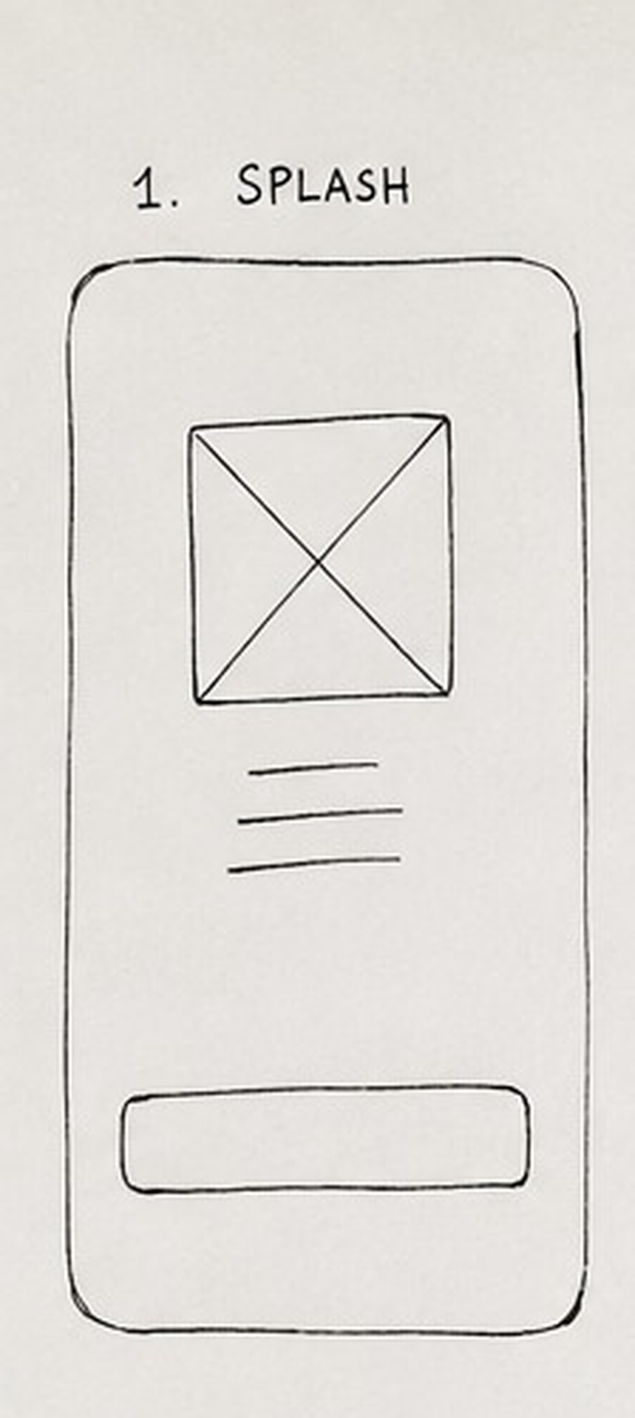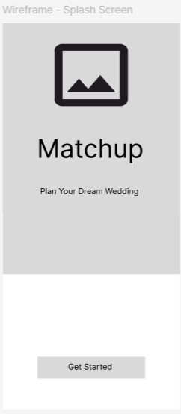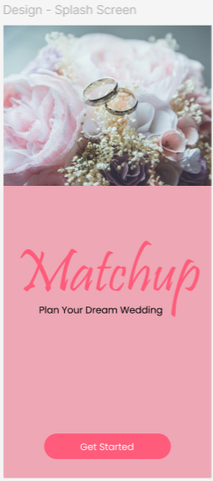

To design my Matchup Wedding Planner App, I first researched modern wedding planning applications and identified the essential features that users would need, such as budget management, guest management, AI assistance, expense tracking, and seating optimization. Based on this research, I planned a simple, elegant, and user-friendly interface that would provide a smooth user experience. I started by creating a rough hand-drawn sketch of the Splash Screen to visualize the basic layout, including the image, app title, tagline, and Get Started button. After finalizing the sketch, I recreated it as a low-fidelity wireframe in Figma using the iPhone 17 Pro Max frame to ensure consistency with a modern smartphone display. The wireframe helped me organize the screen structure, spacing, alignment, and navigation before adding visual elements. Finally, I transformed the wireframe into a high-fidelity UI by applying a soft pink color palette, elegant typography, wedding-themed images, and interactive buttons to create an attractive and professional design. This step-by-step design process allowed me to move from an initial concept to a polished final interface while ensuring that the application remained visually appealing, easy to navigate, and aligned with the overall theme of wedding planning.

